1 ) What do you understand By Database

A database is information that is set up for easy access, management and updating.

Database are used for storing, maintaining and accessing any sort of data.

2 ) What is Normalization?

Normalization is the process of minimizing redundancy (duplicity) from a relation or set of relations.

Redundancy in relation may cause insertion, deletion and updation anomalies. So, it helps to minimize the redundancy in relations.

3 ) What is Difference between DBMS and RDBMS?

|  |  |
| --- | --- |
| DBMS | RDBMS |
| DBMS application store data as file | RDBMS application store data in a tabular form. |
| In DBMS data is generally stored in either a hierarchical form or a navigation form. | In RDBMS, the tables have an identifier called primary key and the data value are stores in the form of tables. |
| Normalization is not present in DBMS | Normalization is present in RDBMS |
| DBMS dose not support distributed database. | RDBMS support distributed database. |

4 ) What do you understand By Data Redundancy?

Data redundancy occurs when the same piece of data exists in multiple places.

data redundancy can cause data inconsistency, which can provide a company with unreliable and/or meaningless information.

5 ) What is DDL Interpreter?

Data Definition Language (DDL) interpreter is CREATE , ALTER etc.

The result of this interpretation is a set of a table that contains the meta-data which is stored in the data dictionary.

6 ) What is DML Compiler in SQL?

A DML (data manipulation language) refers to a computer programming language that allows you to add (insert), delete (delete), and update data in a database.

7) What is SQL Key Constraints writing an Example of SQL Key Constraints.

Primary Key:

A primary key is a column of table which uniquely identifies each

tuple (row) in that table.

Primary key enforces integrity constraints to the table.

Only one primary key is allowed to use in a table.

Unique Key:

Unique key constraints also identifies an individual table uniquely in a relation or table.

A table can have more than one unique key unlike primary key.

Unique key constraints can accept only one NULL value for column.

Foreign Key:

When, "one" table's primary key field is added to a related "many" table in order to create the common field which relates the two tables, it is called a foreign key in the "many" table.

In the example given below, salary of an employee is stored in salary table.

Relation is established via is stored in "Employee" table. To identify the salary of "Jforeign key column “Employee_ID_Ref” which refers “Employee_ID” field in Employee table.

8 ) What is save Point? How to create a save Point write a Query?

A SAVEPOINT is a point in a transaction when you can roll the transaction back to a certain point without rolling back the entire transaction.

The syntax for a SAVEPOINT command is as shown below.

SAVEPOINT SAVEPOINT_NAME;

This command serves only in the creation of a SAVEPOINT among all the transactional statements. The ROLLBACK command is used to undo a group of transactions.

9 ) What is trigger and how to create a Trigger in SQL?

A trigger is a stored procedure in database which automatically invokes whenever a special event in the database occurs

For example, a trigger can be invoked when a row is inserted into a specified table.

create trigger [trigger_name] [before | after] {insert | update | delete} on [table_name] [for each row] [trigger_body]

TASK :

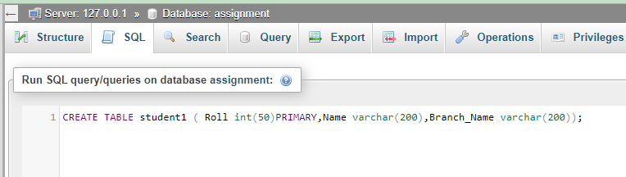1. Create Table Name : Student and Exam

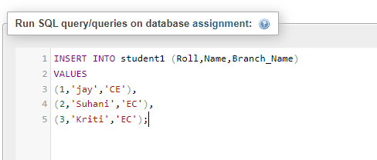

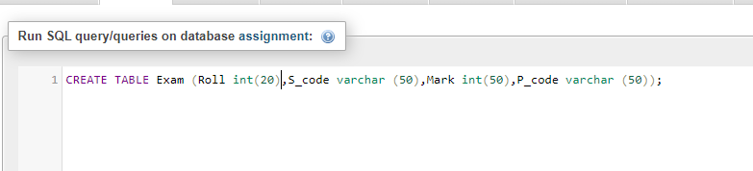

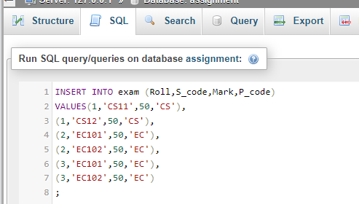

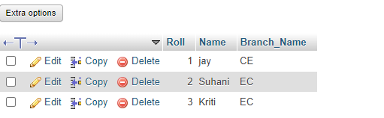OUTPUT

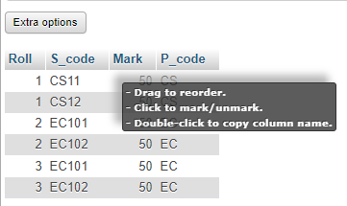

2 ) Create table given below: Employee and Incentive Table

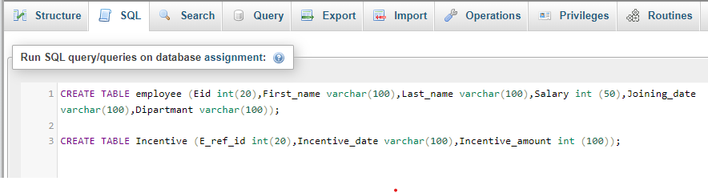

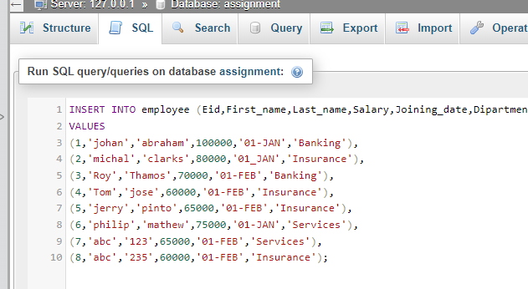

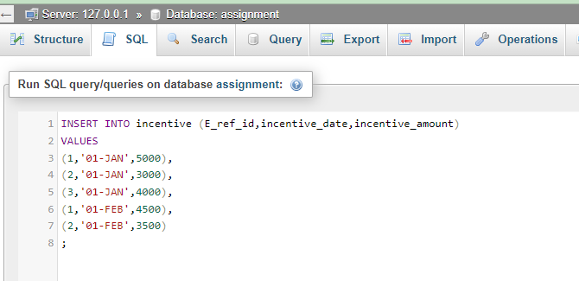

A ) Get First Name from employee table using Tom name “Employee Name”

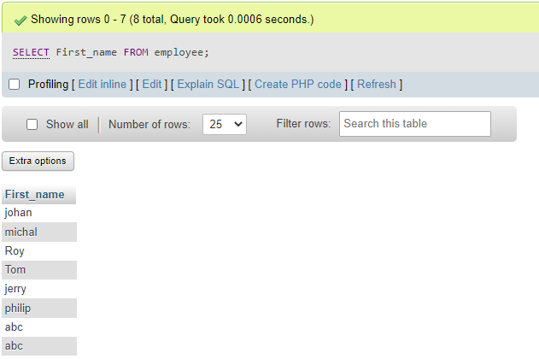

B ) Get FIRST_NAME, Joining Date, and Salary from employee table.

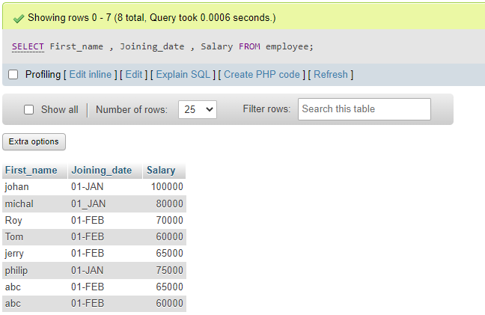

C ) Get all employee details from the employee table order by First Name Ascending and Salary descending?

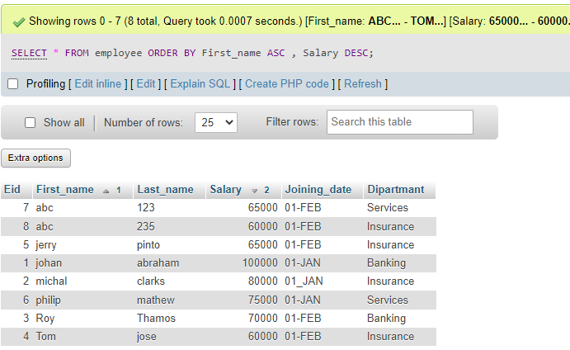

D ) Get employee details from employee table whose first name contains ‘J’.

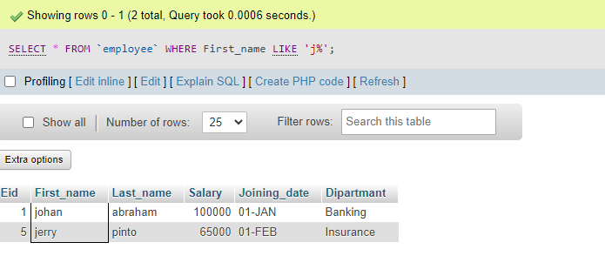

E ) Get department wise maximum salary from employee table order by salary ascending?

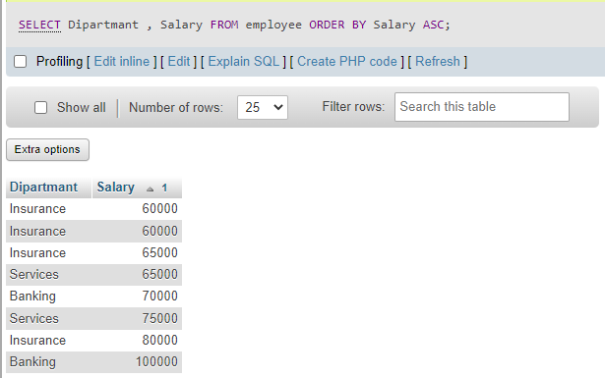

F ) Select first name, incentive amount from employee and incentives table for those employees who have incentives and incentive amount greater than 3000

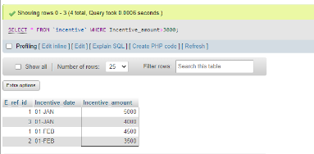

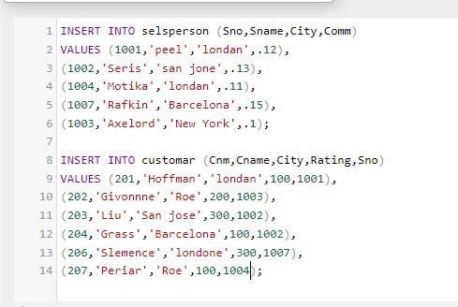3 ) Create table given below: Salesperson and Customer

A ) Names and cities of all salespeople in London with commission above 0.12

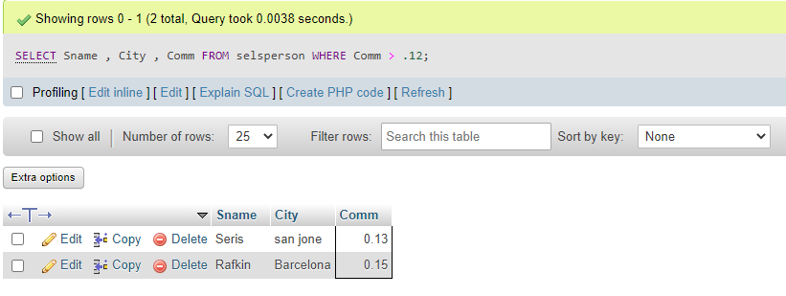

B ) All salespeople either in Barcelona or in London

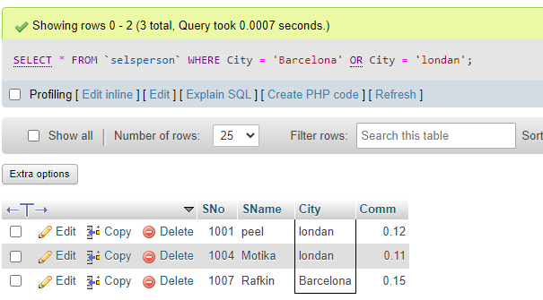

C ) All salespeople with commission between 0.10 and 0.12. (Boundary values should be excluded).

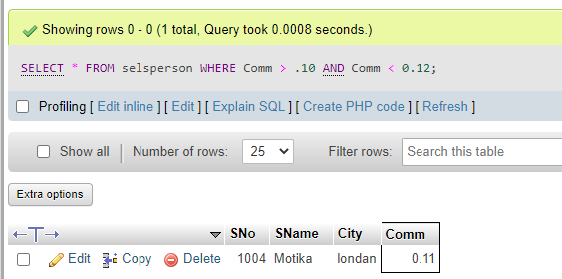

D ) All customers excluding those with rating <= 100 unless they are located in Rome

